
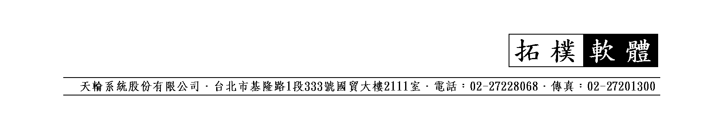
Item No. 000000012345
Porcelain teapot, 4-1/2" high.
Each in a white box.
Note: this pot is for decorative purpose only.
Don't use it on an oven. The manufacturer shall not be held responsible for any misuse on the part of the user.
1 pc/box, 12 pc/1.56'/7 kg
NT$400/doz FOB TWN (00005 友展企業)
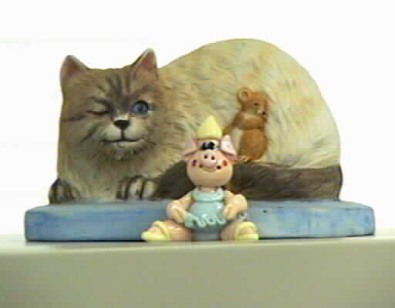
Item No. 000000012345a
Porcelain teapot, 4-1/2" high.
Each in a white box.
Note: this pot is for decorative purpose only.
Don't use it on an oven. The manufacturer shall not be held responsible for any misuse on the part of the user.
1 pc/box, 12 pc/1.56'/7 kg
NT$10/pc FOB (00001 Torus)
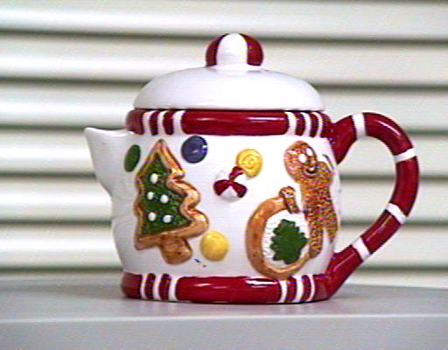
Item No. 000000046
Porcelain teapot, 4-1/2" high.
Each in a white box.
Note: this pot is for decorate purpose only. Don't use it on an oven. The manufacturer shall not be held responsible for any misuse on the part of the user.
1 pc/box, 12 pc/1.8'/7 kg
NT$300/doz FOB Keelung (00000)
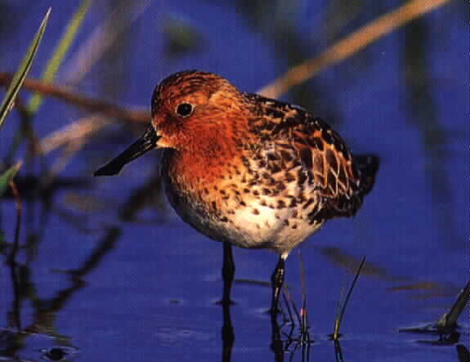
Item No. 000000046N
Porcelain teapot, 4-1/2" high.
Each in a white box.
Note: this pot is for decorative purpose only. Don't use it on an oven. The manufacturer shall not be held responsible for any misuse on the part of the user.
1 set/box, 12 pc/1.56'/7 kg
NT$18.016/pc FOB HK (T-002 山夫實業)
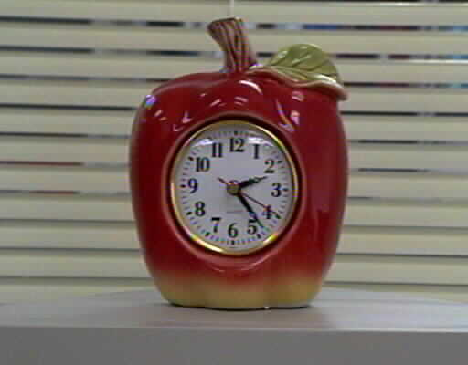
Item No. 000000047A
Porcelain teapot, 4-1/2" high.
Each in a white box.
Note: this pot is for decorative purpose only. Don't use it on an oven. The manufacturer shall not be held responsible for any misuse on the part of the user.
1 pc/box, 12 pc/1.8'/7 kg
NT$10/pc FOB KEELUNG (00003 強昇紡織)

